

NYAMBARIA BOYS’ 2025 PREDICTION
KCSE PROJECTION EXAM
COMPUTER STUDIES
451/1
PAPER 1 (THEORY)
TIME: 2½ HOURS

NAME……………………………………………………………………………………….
SCHOOL……………………………………………… SIGN………………………..
INDEX NO……………………………………………. ADM NO……………………

Kenya certificate of secondary education

Instructions to candidates
- This paper consists of TWO sections; A and B
- answer all questions in sections A.
- Answer question 16 and any other THREE questions from section B.

for examiners use only
section | Question
A | 1 – 15
B | 16
 | 17
 | 18
 | 19
 | 20
Total marks

SECTION A (40MKS)
Answer all the questions in this section
- A computer must go through the process of booting before use. State what happens during Power On Self-Test (POST) (1mk)
………………………………………………………………………………………………………
………………………………………………………………………………………………………
………………………………………………………………………………………………………

- State two differences between a traditional mouse and a trackball (2mks)
………………………………………………………………………………………………………
………………………………………………………………………………………………………
………………………………………………………………………………………………………
………………………………………………………………………………………………………

- State any two circumstances where sound output devices would not be appropriate (2mks)
………………………………………………………………………………………………………
………………………………………………………………………………………………………
………………………………………………………………………………………………………

4. Software can be categorized according to end user licence. Differentiate between a proprietary software and an open source software (2mks)
………………………………………………………………………………………………………
………………………………………………………………………………………………………
………………………………………………………………………………………………………
………………………………………………………………………………………………………

- State the function of each of the following features when creating a word processing document
- Word wrap (1mk)
………………………………………………………………………………………………………
………………………………………………………………………………………………………

- Watermark (1mk)
………………………………………………………………………………………………………
………………………………………………………………………………………………………

- Clipboard (1mk)
………………………………………………………………………………………………………
………………………………………………………………………………………………………

- Different types of cables are suitable for different applications
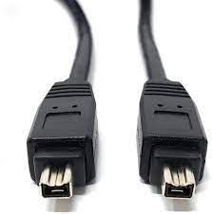
- Identify the cables in the diagram above (1mk)
………………………………………………………………………………………………………

- State one advantage of using the above cable (1mk)
………………………………………………………………………………………………………
………………………………………………………………………………………………………

- State any two factors to consider when selecting a computer for an organization (2mks)
………………………………………………………………………………………………………
………………………………………………………………………………………………………
………………………………………………………………………………………………………

- Identify the following symbols as used in spreadsheet (3mks)
C
B
A
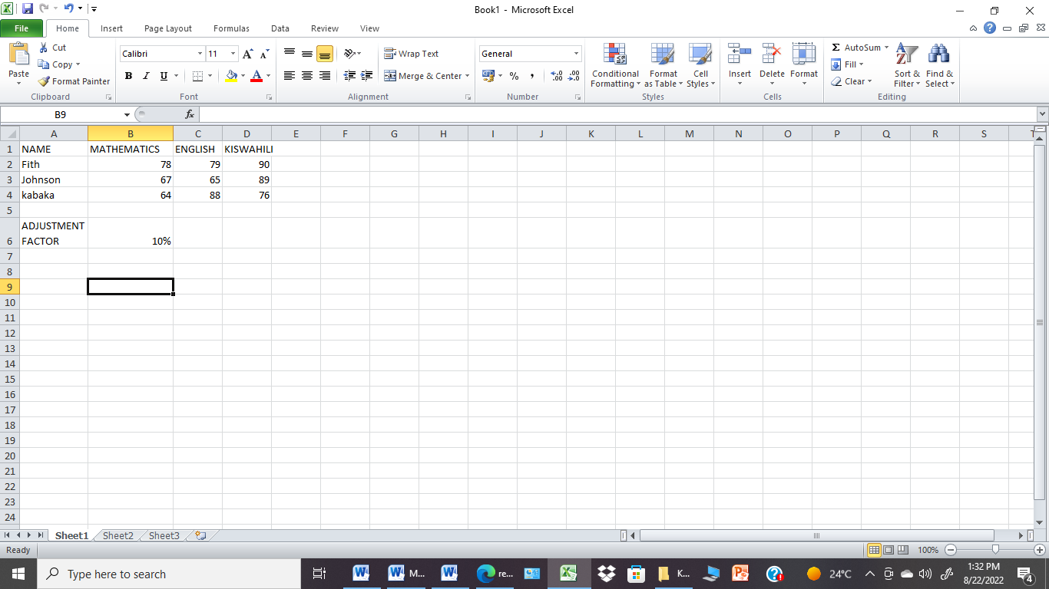

- A ………………………………………………………………………………………………
- B
………………………………………………………………………………………
- C …………………………………………………………………………………………….

- The formula D10*E12 was initially stored in in cell F10 of a spreadsheet. Write the formula as it would appear when copied to cell M20 of the same spreadsheet (1mk)
………………………………………………………………………………………………………
………………………………………………………………………………………………………

- Write a formula in cell E2 that can be copied to the other cells to display the positive adjusted marks for mathematics using the value in cell B6 (2 mks)
………………………………………………………………………………………………………
………………………………………………………………………………………………………
………………………………………………………………………………………………………
………………………………………………………………………………………………………

- The operating system is known to be very critical in the operation of a computer.
- State how the operating system handles errors in a computer (2 Marks)
………………………………………………………………………………………………………
………………………………………………………………………………………………………
………………………………………………………………………………………………………

- State the importance of the feedback mechanism in a system (1 mk)
………………………………………………………………………………………………………
………………………………………………………………………………………………………

- State one disadvantage of the feedback mechanism (1 mk)
………………………………………………………………………………………………………
………………………………………………………………………………………………………

- Differentiate between universal resource locator and hyperlink as used when connecting to the internet. (2 mks)
………………………………………………………………………………………………………
………………………………………………………………………………………………………
………………………………………………………………………………………………………

- A database is the best application to manage and manipulate organization data;
- Distinguish between a candidate key and a primary key in a database (2 mks)
………………………………………………………………………………………………………
………………………………………………………………………………………………………
………………………………………………………………………………………………………

- State any two functions of a query (2 mks)
………………………………………………………………………………………………………
………………………………………………………………………………………………………
………………………………………………………………………………………………………

- Give the function of cache memory (1mk)
………………………………………………………………………………………………………
………………………………………………………………………………………………………

- With aid of a flowchart, show a selection control structure. (2 mks)

14. An employee in a business company is charged with the responsibility of putting the company advertisement on the internet. State the profession title of the employee entitled with the task of uploading the advertisement on the internet (1mk)
………………………………………………………………………………………………………

(b) State any two roles of a system analyst. (2mk)
………………………………………………………………………………………………………
………………………………………………………………………………………………………
………………………………………………………………………………………………………

15(a) Describe how the operating system manages the computer Memory. (2mks)
………………………………………………………………………………………………………
………………………………………………………………………………………………………
………………………………………………………………………………………………………
………………………………………………………………………………………………………

(b)Elaborate the application of Artificial intelligence in Artificial neural network (2mks)
………………………………………………………………………………………………………
………………………………………………………………………………………………………
………………………………………………………………………………………………………

SECTION B (60mks)
Answer question 16 and any other three questions
16. (a)Study the flowchart below and use it to answer questions that follow.
- Write a pseudocode for the flowchart below. (7 marks)
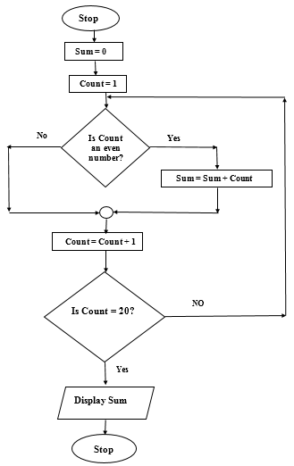
- Explain the purpose of the above flowchart. (2 mks)
………………………………………………………………………………………………………
………………………………………………………………………………………………………
………………………………………………………………………………………………………

- Determine the output from the flowchart if count is:
- 4 (2 mks)
………………………………………………………………………………………………………
………………………………………………………………………………………………………
………………………………………………………………………………………………………

- 12 (2 mks)
………………………………………………………………………………………………………
………………………………………………………………………………………………………
………………………………………………………………………………………………………

- Differentiate between object orientated programming and web scripting language. (2mks)
………………………………………………………………………………………………………
………………………………………………………………………………………………………
………………………………………………………………………………………………………
………………………………………………………………………………………………………

17. Find the value of X in the question below (2mks)
(a) 16₈+1010₂=X₂
………………………………………………………………………………………………………
………………………………………………………………………………………………………
………………………………………………………………………………………………………
………………………………………………………………………………………………………

(b) Perform the following binary operation (2mks)
1010.11+111.10-101.11
………………………………………………………………………………………………………
………………………………………………………………………………………………………
………………………………………………………………………………………………………
………………………………………………………………………………………………………

(c)In a certain coding scheme ,each character occupies 7 bits .Letters of the alphabet are assigned consecutive codes. If letter N is represented by 1010010.Whatis the representation of letter A in this coding scheme? (2mks)
………………………………………………………………………………………………………
………………………………………………………………………………………………………
………………………………………………………………………………………………………

(d)Using 8 bit notation and the 2’s complement perform the following operation leaving your answer in decimal number (4mks)
4₁₀+(-7₁₀)
………………………………………………………………………………………………………
………………………………………………………………………………………………………
………………………………………………………………………………………………………
………………………………………………………………………………………………………
………………………………………………………………………………………………………

(e) Differentiate between pure binary and BCD code as used in data representation (2mks)
………………………………………………………………………………………………………
………………………………………………………………………………………………………
………………………………………………………………………………………………………
………………………………………………………………………………………………………

f)Brian a supermarket owner complains that management of daily sales is becoming overwhelming
(i) Advice Brian on a retail system that he needs to acquire (1mk)
………………………………………………………………………………………………………
………………………………………………………………………………………………………
(ii) State two input devices that are used in the above stated retail system (2mks)
………………………………………………………………………………………………………
………………………………………………………………………………………………………
………………………………………………………………………………………………………

18. (a) State and explain any two data transmission impairments (4mks)
………………………………………………………………………………………………………
………………………………………………………………………………………………………
………………………………………………………………………………………………………
………………………………………………………………………………………………………
………………………………………………………………………………………………………

(b)State the roles of the following devices/equipment used in networking (3mks)
(i) Brouter
………………………………………………………………………………………………………
………………………………………………………………………………………………………
(ii) Data terminal equipment
………………………………………………………………………………………………………
………………………………………………………………………………………………………
(iii) Repeater
………………………………………………………………………………………………………
………………………………………………………………………………………………………

18. The diagram below shows a layout of a computer network as used in an industrial firm. A work station and a printer are located in every consultation room

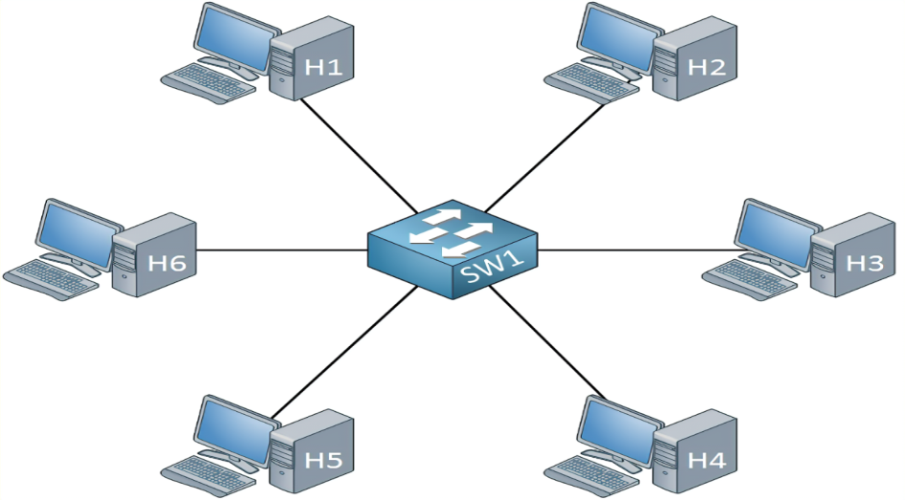
(a) Identify the type of network topology depicted above (1mk)
………………………………………………………………………………………………………
(b)List any three disadvantages associated with the network topology identified in (a) above3mk
………………………………………………………………………………………………………
………………………………………………………………………………………………………
………………………………………………………………………………………………………

- An employee sneaked into the accounts office, gained access to the payroll and adjusted his salary for his personal gain.
- Identify two types of crimes the employee committed (2mks)
………………………………………………………………………………………………………
………………………………………………………………………………………………………
- Give two recommendations to the company to prevent such future occurrences (2mks)
………………………………………………………………………………………………………
………………………………………………………………………………………………………
………………………………………………………………………………………………………

19. (a) The management of Mawingu county government opt to employ a Database administrator. State two roles of this employee. (2 mks)
………………………………………………………………………………………………………
………………………………………………………………………………………………………
(b)(i) Explain four circumstances that may necessitate an organization to develop a new information system. (8 marks)
………………………………………………………………………………………………………
………………………………………………………………………………………………………
………………………………………………………………………………………………………
………………………………………………………………………………………………………
………………………………………………………………………………………………………
………………………………………………………………………………………………………
………………………………………………………………………………………………………
………………………………………………………………………………………………………
………………………………………………………………………………………………………
………………………………………………………………………………………………………

(ii)A school opted to use a change-over strategy where the new system and old system are run concurrently as the performances of the two systems are compared.
- Name the type of change-over approach above. (1 mark)
………………………………………………………………………………………………………

- Explain two benefits that the school may get as a result of this approach. (4 marks)
………………………………………………………………………………………………………
………………………………………………………………………………………………………
………………………………………………………………………………………………………
………………………………………………………………………………………………………
………………………………………………………………………………………………………

20. A school evaluation system relies heavily data processing to rank students
- Identify and describe the file organization applied by the evaluation system (2 Mks)
………………………………………………………………………………………………………
………………………………………………………………………………………………………
………………………………………………………………………………………………………

- State the data processing method applied by the evaluation system (1 Mk)
………………………………………………………………………………………………………
………………………………………………………………………………………………………
- State any two reasons for your data processing method choice in (20. b) above (2 mks)
………………………………………………………………………………………………………
………………………………………………………………………………………………………
………………………………………………………………………………………………………

- During data collection stage of data processing, data is verified and coded. Define the terms
- Verification (1 mk)
………………………………………………………………………………………………………
………………………………………………………………………………………………………
- Coding (1 mk)
………………………………………………………………………………………………………
………………………………………………………………………………………………………

- Jane is a copy typist at Majengo Holdings, she frequently confuses characters in hand written documents thus replacing them with different characters.
- State the type of data processing error Jane makes (1mk)
……………………………………………………………………………………………………
- State how she can overcome the error (1mk)
………………………………………………………………………………………………………………………………………………………………………………………………
- Peter the technician connected and installed a scanner to the office computer but when testing he realized it was not responding to the scanning commands, state any two possible causes of the failure (2mk)
………………………………………………………………………………………………………
………………………………………………………………………………………………………
………………………………………………………………………………………………………

- Distinguish between disk compression and file compression (2 mks)
………………………………………………………………………………………………………
………………………………………………………………………………………………………
………………………………………………………………………………………………………

- The operating organizes data in a hierarchy. Give any two reasons for the hierarchical organization of data in a computer (2mks)
………………………………………………………………………………………………………
………………………………………………………………………………………………………
………………………………………………………………………………………………………

